Sri Lanka Institute of Information

Technology



Lab Submission

Lab sheet No 09

**IT24100528**

**Karunarathne W.N.S**

**Probability and Statistics | IT2120**

B.Sc. (Hons) in Information Technology

Exercise

Assume that the time taken to bake a batch of cookies is normally distributed with mean 45 minutes and standard deviation 2 minutes.

i. Generate a random sample of size 25 for the baking time.

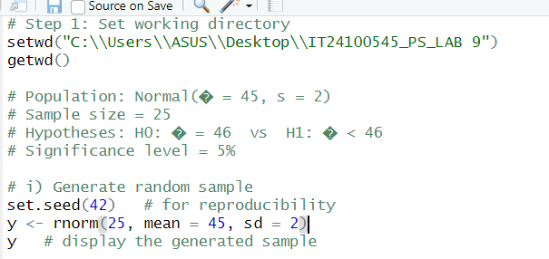

ii. Test whether the average baking time is less than 46 minutes at a 5% level of significance.

